Name: ___________________________________ Date: ___________________________

Structure of the Brain

Directions: Label the Parts to the diagram below.

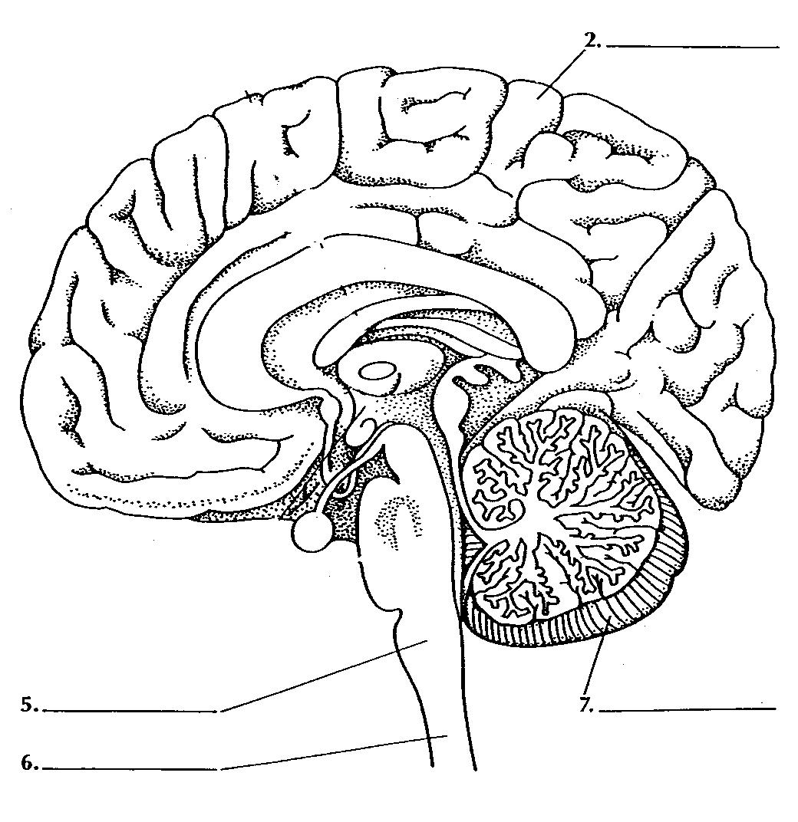

The Nervous System

Get the Big Picture. Read the paragraphs in the below and look at the diagram. Then answer the questions that follow.

The nervous system gives directions to all the other systems in your body. It also gets information from your senses and keeps track of how well the different parts of your body are working together. The nervous system is made up of two parts: the central nervous system (CNS), and the peripheral nervous system (PNS). Peripheral means “not central.” Your brain and spinal cord make up your CNS and send and receive messages through your PNS.

Your senses allow you to perceive the world by seeing, hearing, feeling, tasting and smelling. Your sense organs collect information about the world and send it to your brain. The brain decodes the signals and makes them meaningful.

Many drugs act to disrupt the normal functioning of the nervous system. Drugs can change your brain’s ability to think and to control the rest of your body.

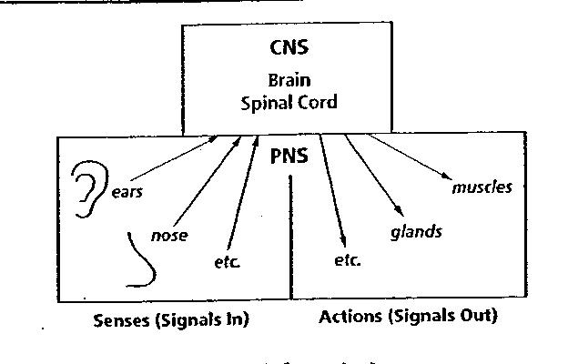

1. How does your central nervous system receive information?

2. Which part of the nervous system do the nerves in your skin belong to?

3. You may not think that caffeine is a drug, but it is. When you drink a soft drink that contains caffeine, you may feel jittery. Why do you think this is so?

